Large View: <https://wireframe.cc/VBa5tM>

Medium View: <https://wireframe.cc/0M0Sy9>

Small View: <https://wireframe.cc/U74J6L>

**Site Purpose**: The overall goal of the website is to promote and provide information about the specialized services that this hotel chain offers to meet the needs of temple patrons who come to serve in the temple or who participate in events such as sealings, weddings, receptions, and youth trips. The website reflects the Church culture and is designed to support a temple-oriented theme as well as the concept of being a haven of comfort and accessibility.

**Target Audience:**

**Sean Broadway –**

* **38 yrs old, Contracts Specialist for the Navy**
* **Lives in Dallas, married with 4 children**
* **Visiting Temple while in town for work**
* **Needs breakfast and place to change**

**Ron and Debbie Bennion -**

* **Retired Couple**
* **Live in Chesapeake, VA**
* **Ward Temple trip**
* **Need changing-room, shuttle**

**Site Map**:

**Color Scheme**:

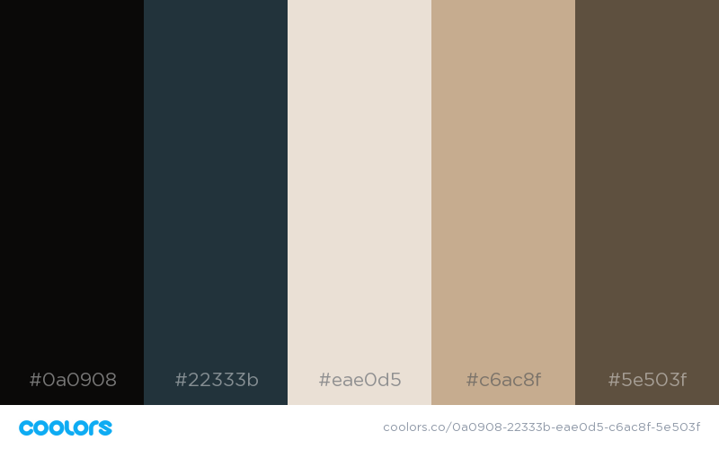

Hex: #0a0908 Hex: #c6ac8f

RGB: 10,9,8 RGB: 198,172,143

Black Medium beige

Hex: #22333b Hex: #5e503f

RGB: 34,51,54 RGB: 94,80,63

Dark teal Brown

Hex: #eae0d5

RGB: 234,224,213

Light Cream

**Typography:**

<link href="https://fonts.googleapis.com/css?family=**Assistant|Cormorant+Upright**&display=swap" rel="stylesheet">

font-family: 'Cormorant Upright', serif;

font-family: 'Assistant', sans-serif;

Heading 1

Heading 2

Heading 3

**Heading 4**

**Heading 5**

**Heading 6**

Paragraph

Large View

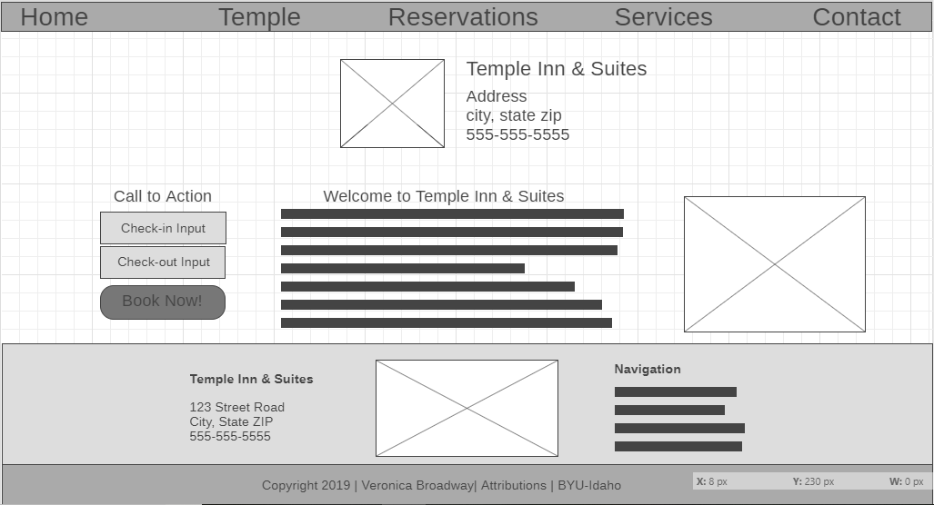

Medium View

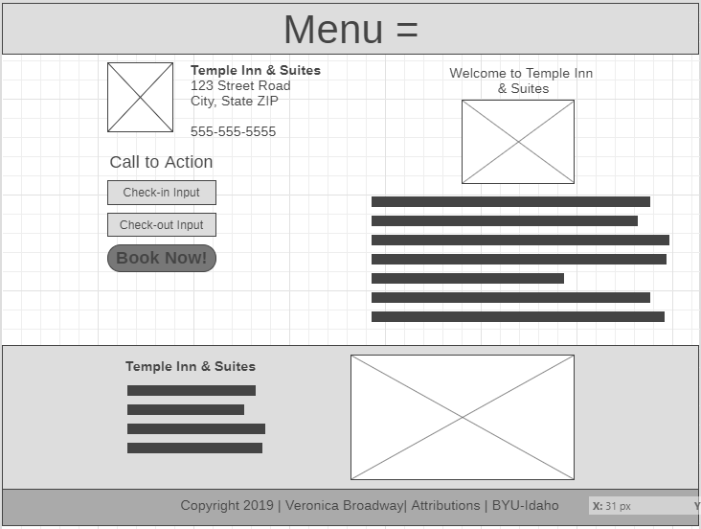

Small View

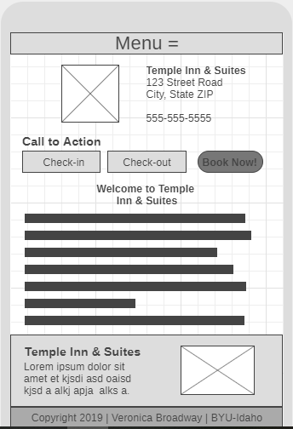

Directions:

Follow I-495 to MD-187 S. Take exit 35 to 1-495 N. Follow MD-187 to Montgomery Ln.